

**EC60064**

**Biomedical System Engineering and Automation**

**Experiment-3**

**Report**

Prepared by

Sai Joshitha Annareddy

21EE62R10

MTech

Control systems engineering

Question 1:

Problem Statement:

**Considering two ECG signal files: 106m_15.mat and 230m_11.mat (sampled at 200 Hz), perform the following tasks sequentially on Python for both the signals. Plot the signals after each operation.**

1. **Use Butterworth Filters of order 8,4 and 2 for Lowpass Filtering with cutoff frequency 11Hz and also High pass filtering with cutoff frequency 5Hz and then perform the following operation for all 3 sets of filters (of order 8,4 and 2).**

Theory: The Butterworth filter is a type of signal processing filter designed to have as flat frequency response as possible (no ripples) in the pass-band and zero roll off response in the stop-band. The low pass Butterworth filter and high pass butter worth filter is designed using signal. butter function in python with input order and normalized cut-off frequency

Normalised cut off frequency is given as

(cf/fs) *2

Where…

cf is cut off frequency and

fs= sampling frequency

Different order is chosen and Butterworth filter is designed and signal is filtered using those filter and corresponding graphs are plotted below

1. **Derivative Operation: Pass the output of the above operation to a derivative operator specified as: y(n) = 1 /14 {2𝑥(𝑛) + 𝑥 (𝑛 − 1) + 𝑥 (𝑛 − 2) – 𝑥 (𝑛 − 3) – 𝑥 (𝑛 − 4) − 2𝑥 (𝑛 − 5)}**

The above filter is transformed into z domain and implemented in python as 1/14(2+z^-1+z^-2-z^-3-z^-4-2*z^-5)

1. **Squaring: Square the above obtained output.**
2. **Integration: Pass the output of the above operation to an integration operator whose IIR transfer function is defined as: 𝐻(𝑧) = 1/ 16 {1 – 𝑧^−16/ 1 – 𝑧^−1}**

This integration filter is carried by placing all 1s in numerator as we divide 1 – 𝑧^−16/ 1 – 𝑧^−1 we get 1+z^-1+z^-2+z^-3………. +z^-15

1. **QRS Complex Detection: Detect QRS complexes in the above obtained output using a simple threshold-based method. Initially, take the threshold value equal to 95% of the maximum value of the output obtained from last operation. Then, go on decreasing it and observe the changes in your result.   
   Heart Rate Calculation: Use the information of the above obtained output to calculate the averaged heart rate.**
2. **Compare changes among the signal and avg. heart rate among the 3 different order sets of filters used.**

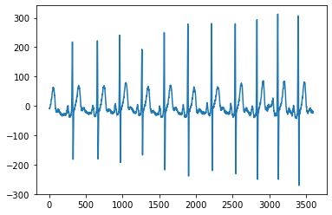

**Figure 1: INPUT ECG SIGNAL1**

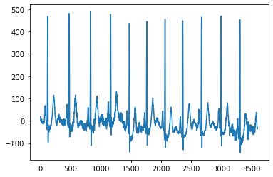

**Figure 2: INPUT ECG SIGNAL2**

**Figures of two signals for Butterworth filter of order 2:**

1. **Input signal ECG 1 AND ECG2 are passed through Butterworth Low pass filter**

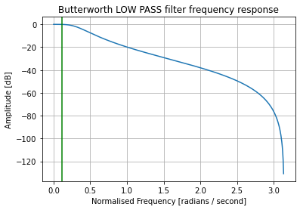

**Figure 3: Butterworth Low pass filter for cut off frequency 11hz**

**The signal is passes through above filter and the output results are as shown..**

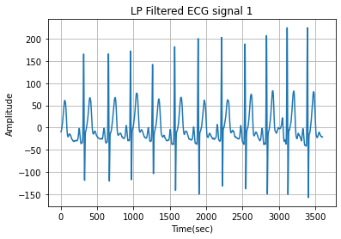

**Figure 4: Low pass filter filtered signal 1**

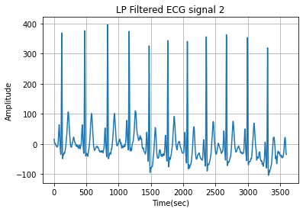

**Figure 5: Low pass filter filtered signal 2**

**ECG signal after passing through Low pass filter signal passed through butter worth high pass filter**

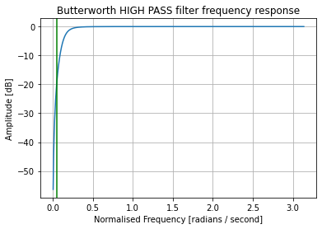

**Figure 6 : Butterworth High pass filter for cut off frequency 5hz**

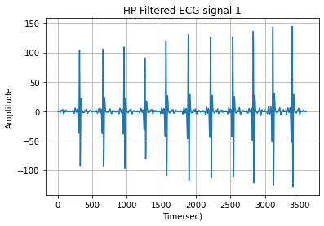

**Figure 7 : High pass filtered ECG SIGNAL1**

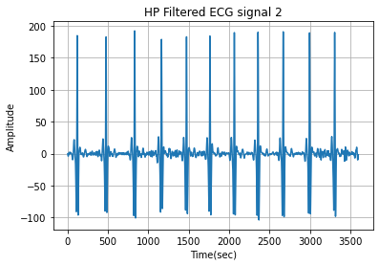

**Figure 8 : High pass filtered ECG SIGNAL 2**

**b)  
Derivative Operation: Pass the output from the filtered signal to a derivative filter specified as: y(n) = 1 /14 {2𝑥(𝑛) + 𝑥 (𝑛 − 1) + 𝑥 (𝑛 − 2) – 𝑥 (𝑛 − 3) – 𝑥 (𝑛 − 4) − 2𝑥 (𝑛 − 5)}**

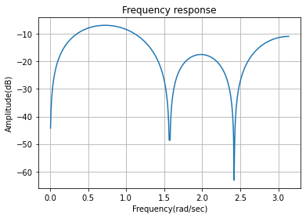

**Figure 9 : Derivative filter**

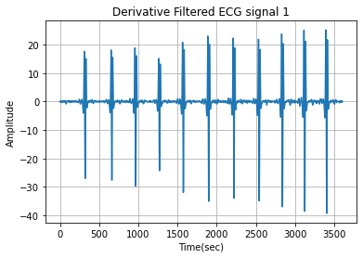

**Figure 10: Derivative filtered signal1**

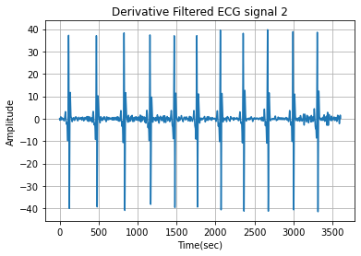

**Figure 11 :Derivative filtered signal 2**

**c)Squaring: Square the above obtained output from derivative filter**

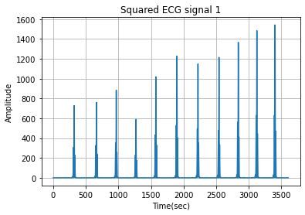

**Figure 12 : filtered signal 1 after squaring**

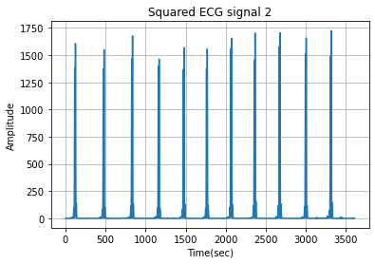

**Figure 13 : filtered signal 2 after squaring**

**d)Integration:** This integration filter is carried by placing all 1s in numerator as we divide 1 – 𝑧^−16/ 1 – 𝑧^−1 we get 1+z^-1+z^-2+z^-3………. +z^-15

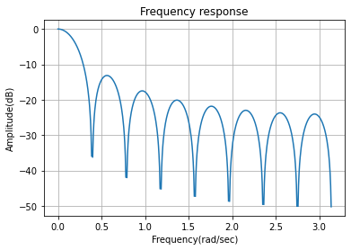

**Figure 14 :Integration filter**

**Pass the output of the above operation to an integration operator whose IIR transfer function is defined as: 𝐻(𝑧) = 1/ 16 {1 – 𝑧^−16/ 1 – 𝑧^−1}**

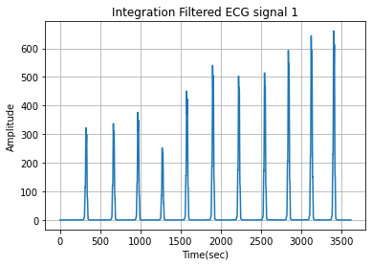

**Figure 15: filtered ecg signal1 through integration filter**

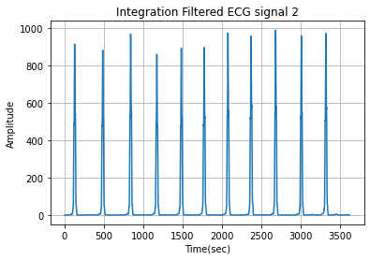

**Figure 16 :filtered ecg signal 2 through integration filter**

**e)Figures for threshold graphs for different thresholds of 0.4,0.65 and 0.95 % of max value.**

**Beats per minute is calculated for the threshold of 95%,65%,40% of max value and mentioned in conclusions.**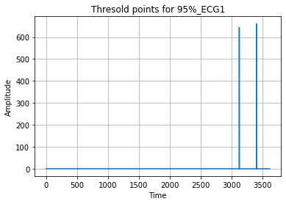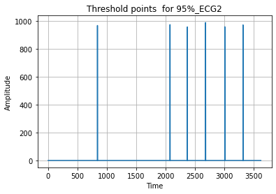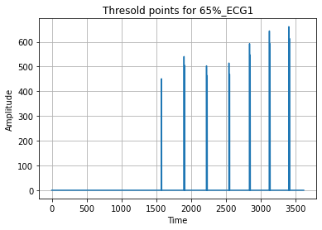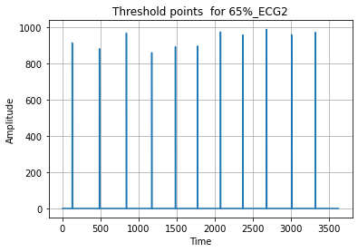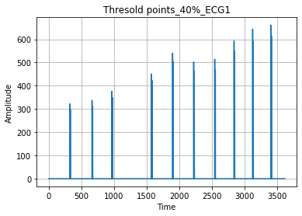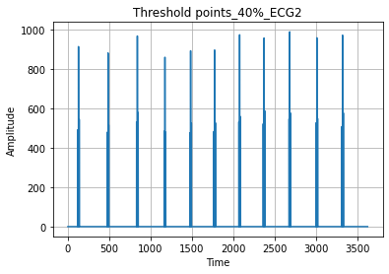

**This is the end of all series of operations done on signal 1 and 2 after passing through butter worth filter of order 2.**

**The similar steps are followed and the graphs are obtained for different Butterworth filter orders 4 and 8**

**Figures of two signals for Butterworth filter of order 4:**

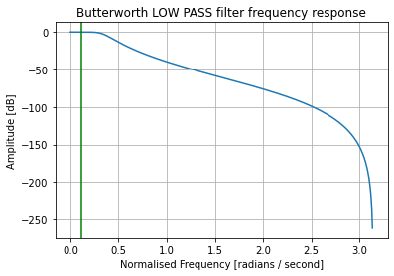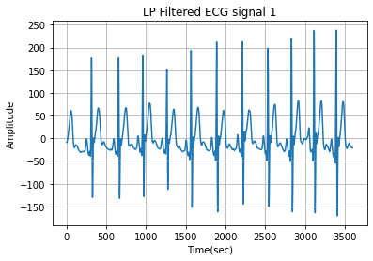

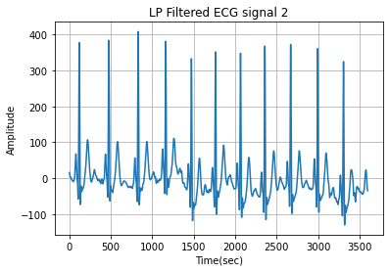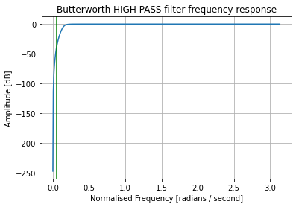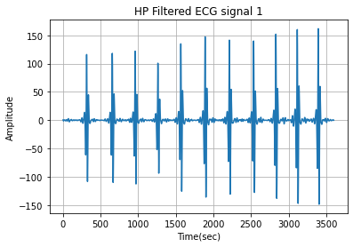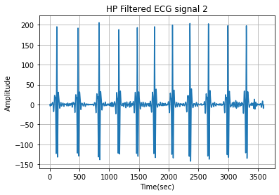

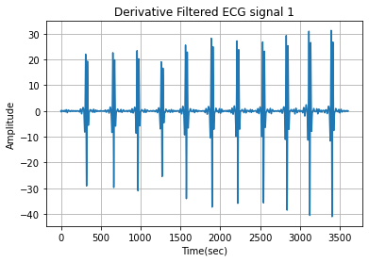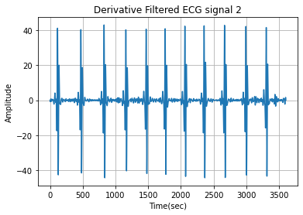

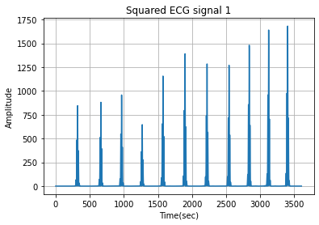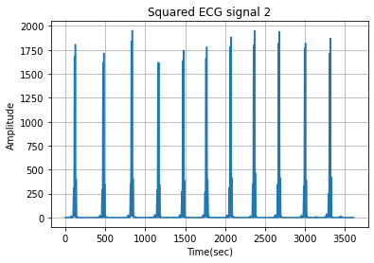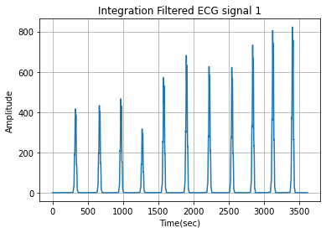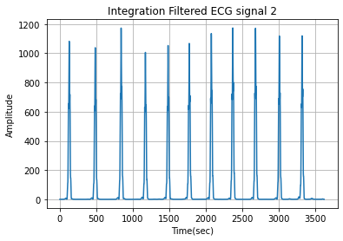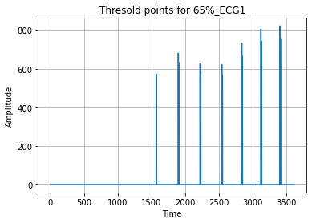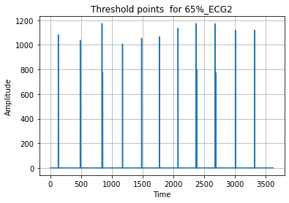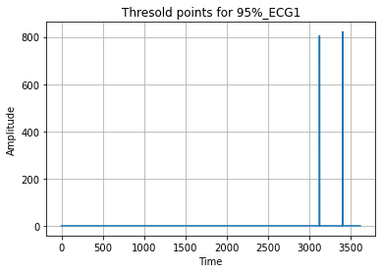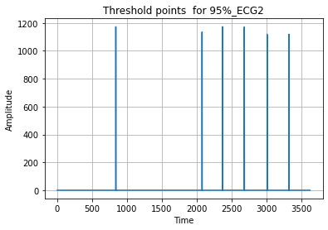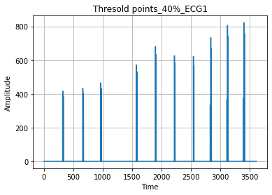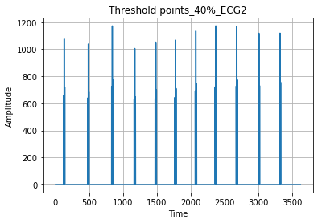

**Figures of two ECG signals for Butterworth filter of order 8:**

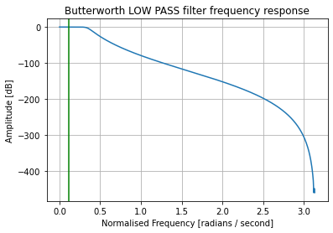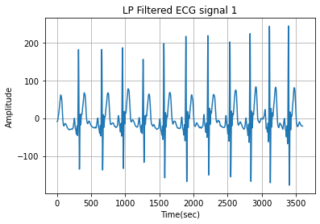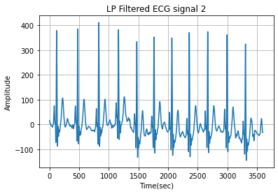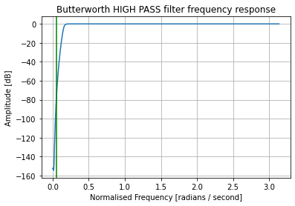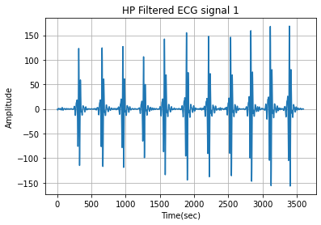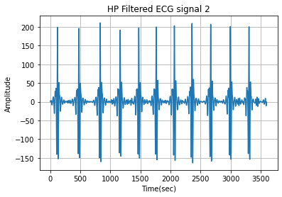

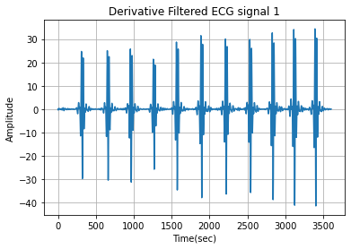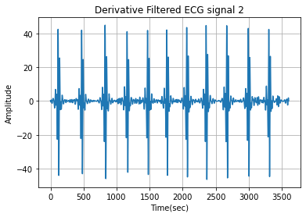

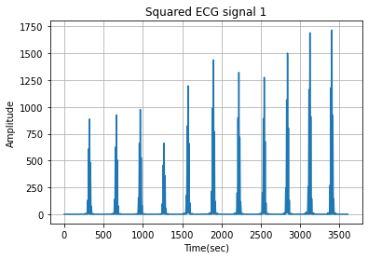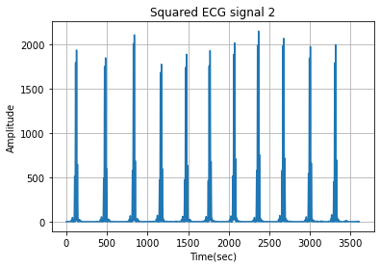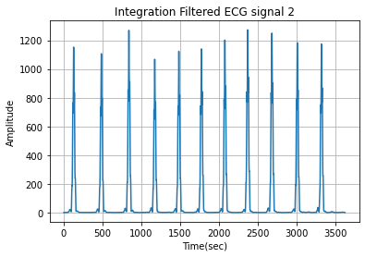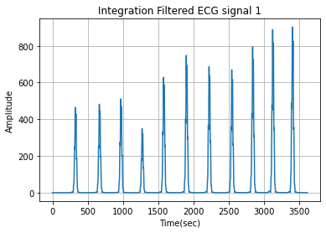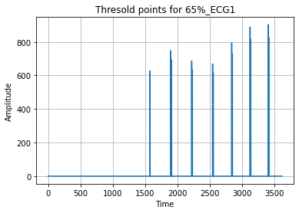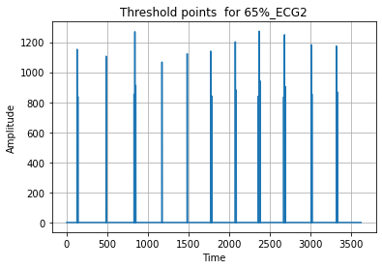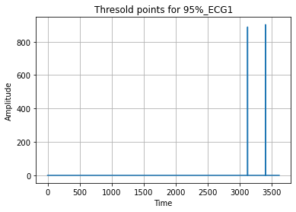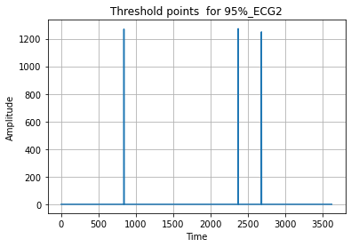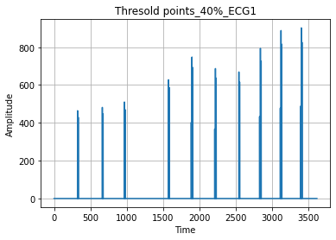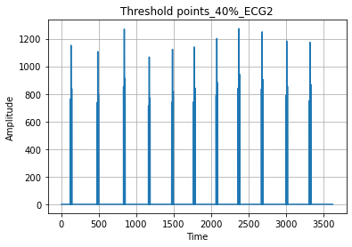

CONCLUSIONS:

f) BPM= Beats per minute (Average Heart rate)

FOR order 2:

FOR THRESHOLD 0.4 OF MAX VALUE, BPM FOR SIG1= 48.977736518062635, BPM FOR SIG2=200.6757070554824

FOR THRESHOLD 0.65 OF MAX VALUE, BPM FOR SIG1= 22.69587857418936, BPM FOR SIG2=1.7284219978131636

FOR THRESHOLD 0.9 OF MAX VALUE, BPM FOR SIG1= 0.21505376344086022, BPM FOR SIG2=0.763032596752533

order 4:

FOR THRESHOLD 0.4 OF MAX VALUE, BPM FOR SIG1= 120.57751882869643, BPM FOR SIG2=200.0427257067023

FOR THRESHOLD 0.65 OF MAX VALUE, BPM FOR SIG1= 22.054192501864893, BPM FOR SIG2=2.3243172155886325

FOR THRESHOLD 0.9 OF MAX VALUE, BPM FOR SIG1= 0.21505376344086022, BPM FOR SIG2=0.763032596752533

order 8:

FOR THRESHOLD 0.4 OF MAX VALUE, BPM FOR SIG1= 132.50997795940035, BPM FOR SIG2=181.18329292546923

FOR THRESHOLD 0.65 OF MAX VALUE, BPM FOR SIG1= 22.0545533533874, BPM FOR SIG2=51.65988986273977

FOR THRESHOLD 0.9 OF MAX VALUE, BPM FOR SIG1= 0.21505376344086022, BPM FOR SIG2=0.11157601115760112

Question 2:

Problem Statement:

**The files eeg-xx.dat (where xx indicates the channel name) give eight simultaneously recorded channels of EEG signals with the alpha rhythm. The sampling rate is 102 Hz per channel.**

1. **Filter the signals using a Bandpass filter (use 8th order Butterworth filters) with cutoff frequency 13Hz - 8Hz.**

**Butter worth Bandpass filter is designed by combing both high pass and low pass filter cutoff frequencies and**

1. **Cut out a portion from signal eeg-f4.dat with a clear presence of the alpha rhythm. You can select from timestep 80 to 155 for the signal eeg-f4.dat and plot it for use as template or reference signal and perform the following tasks sequentially on Python.**
2. **Plot the cross-spectral density (in dB) between the template and each given signal.**
3. **Study the plots to observe the presence of alpha rhythm in the corresponding signal. And find the corresponding frequency (by observation**

**EEG input signals from 0 to 6 are plotted they have sampling rate of 102hz**

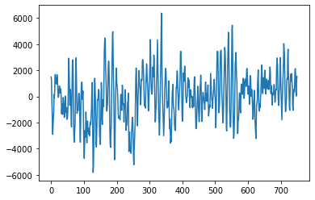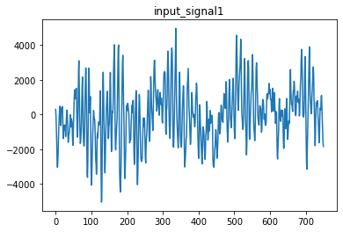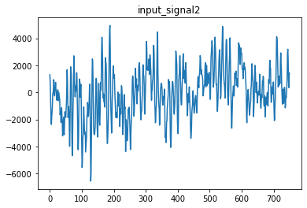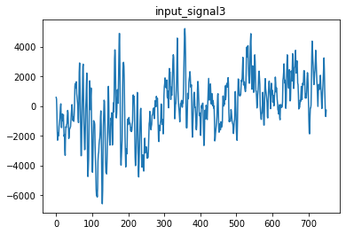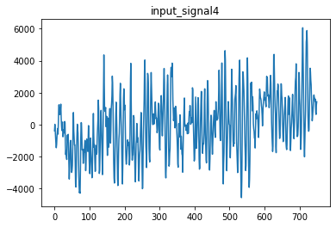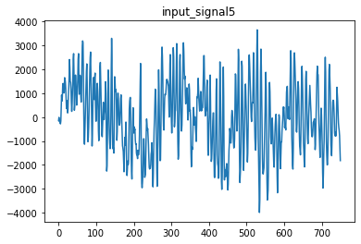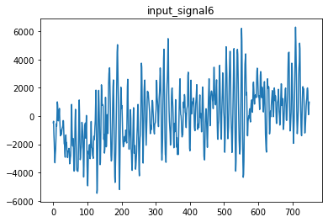

1. Butter worth band pass filter is designed with the combination of low pass and high pass filter with lower cut off frequency of 8hz, higher cut off frequency of 13hz and sampling frequency of 102 hz.

Normalised cut off frequency is given as

(cf/fs) *2

Where…

cf is cut off frequency and

fs= sampling frequency

Order is taken as 8, By above specifications and by using butter command in MATLAB the Butterworth filter is designed as below and input signals are passed through the Butterworth filter

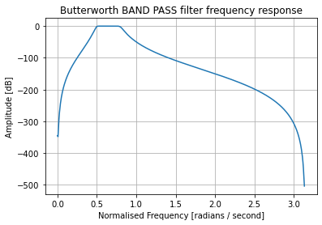

Filtered EEG signals from 0 to 6 after passing through above Butterworth band

Pass filter are shown in below figures  
 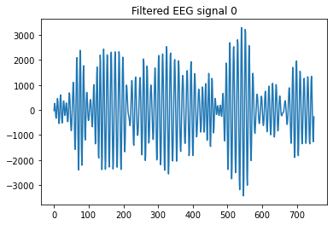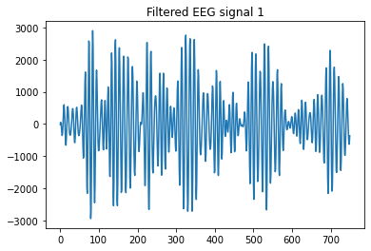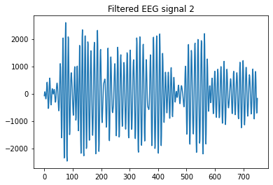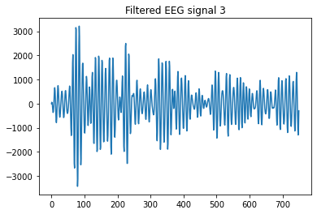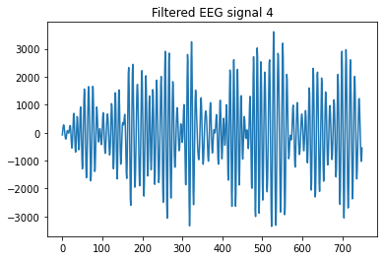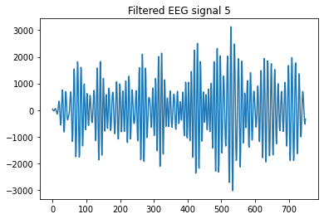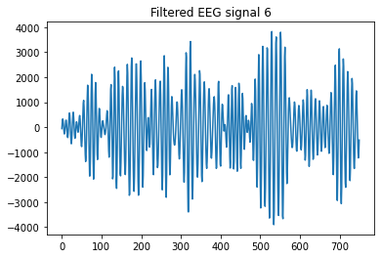

After filtering eeg signals from butterworth band pass filter.

**b)Cut out a portion from signal eeg-f4.dat with a clear presence of the alpha rhythm and select from timestep 80 to 155 for the signal eeg-f4.dat and plot it for use as template or reference signal**

A template is chosen from input signal 4 from 80 to 133 as a template to detetct alpha frequency which ranges from 8 to 12 hz.

The template of the EEG SIGNAL is shown in below figure.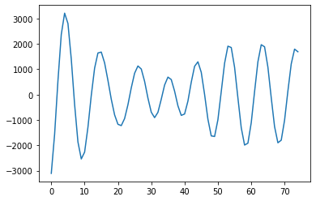

c)Cross spectral density need to be calculated with template and given filtered EEG signals. The procedure without using csd command to calculate cross spectral density is as follows

First, we find the cross correlation between filtered signal and template.

This cross correlation between two signals is found by using correlate function in signal library or we can compute it by convolution of normalized signals of template and filtered signal

Second, after finding cross correlation between the two signals. Fourier transform is calculated in order to obtain cross spectral density

Cross spectral density = Fourier transform (cross correlation).

Here Fourier transform is calculated by fft method in signal library. Fft is computation of fast Fourier transform between two signals.

The below are the figures of cross spectral density of template with filtered signals from 0 to 7

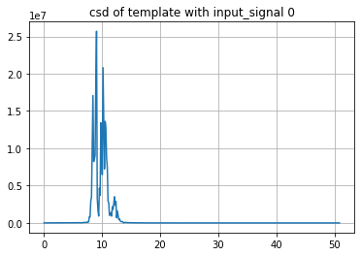

Observed frequency range is from 8 to 12 hz with maximum frequency at 10hz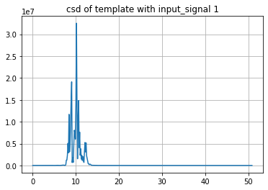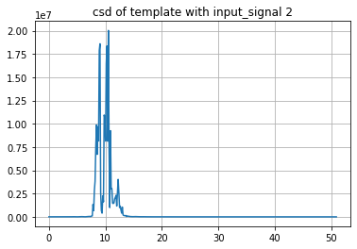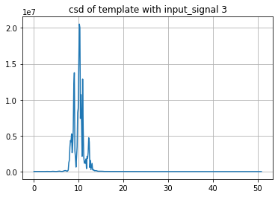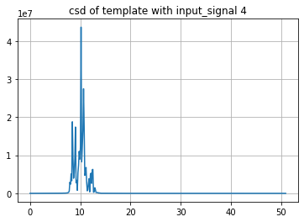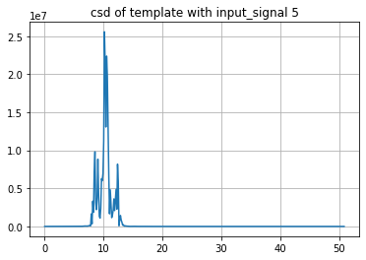

CONCLUSIONS:

d)From all the above cross spectral density graphs we observe that the range of frequencies from 8 to 12 hz which is nothing but the alpha wave in eeg signal.

**We observe the presence of alpha rhythm in the all given EEG signals from above cross spectral density graphs.**